📘 IAM User & Role Management Documentation (AWS)

✅ Prerequisites
- AWS Account (Root access initially)
- IAM permissions:
  - iam:* (for admin setup)

🔐 1. Create IAM Users
Steps:
- Login to AWS Management Console
- Navigate to IAM → Users
- Click “Create user”
- Enter:
  - User name
- 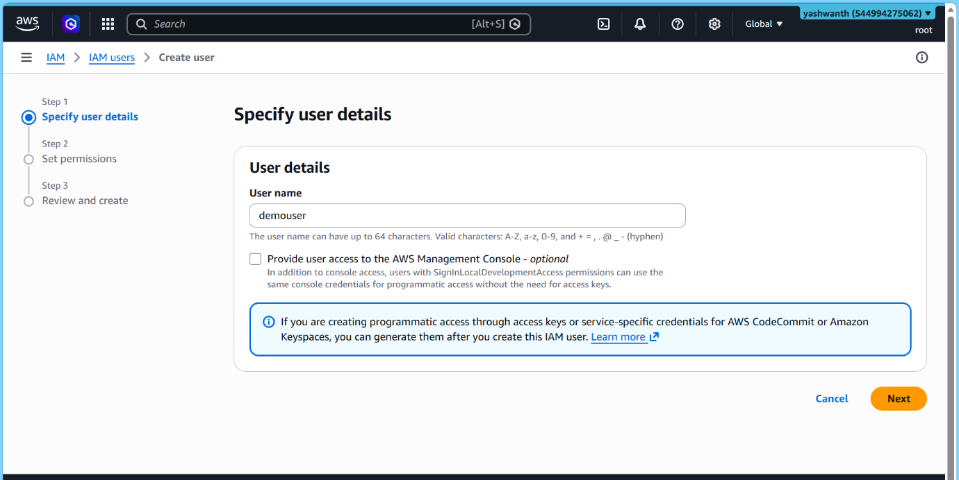

- Select access type:
  - ✅ AWS Management Console access (for UI login)
  - ✅ Programmatic access (for CLI/API)

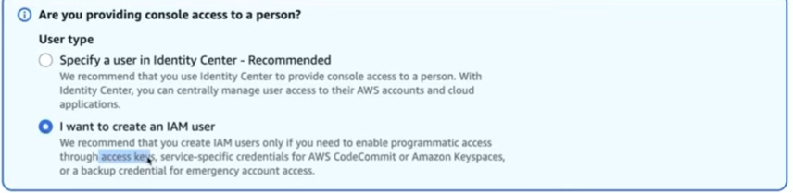

- Set password:
  - Auto-generated or custom
  - Enforce password reset (recommended)
- Click Next

🔗 Assign Permissions
Choose one of the following:
- ✅ Add user to group (Recommended)
- Attach policies directly (not preferred)
- 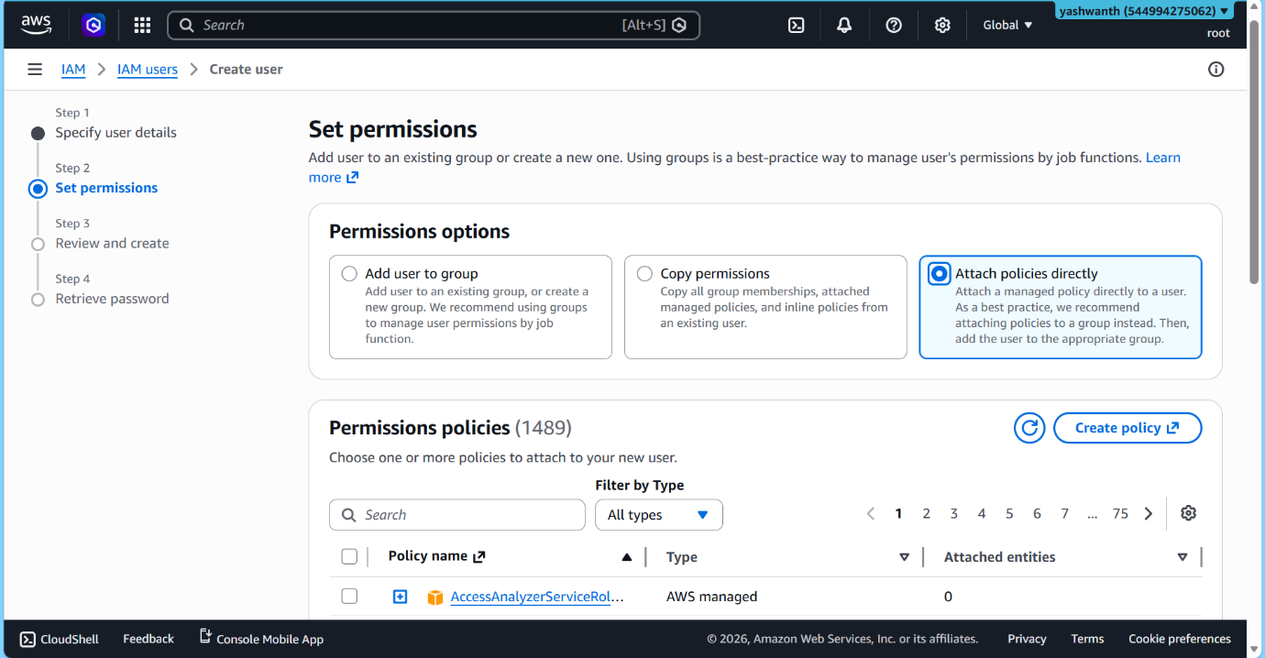

👤 Review & Create
- Verify settings
- Click Create user
- Download:
  - Credentials
  - Access keys (if created)

